Time Value of Money and Basics of Capital Budgeting
Pearland Medical Center’s board recently decided to investigate ways to increase revenues. The organization has the benefit of different revenue streams, including patient revenue and returns on investments. Additionally, the Center has just borrowed $1,000,000 on a five-year loan with annual payment term at a 12 percent rate. The first payment will be due one year from now. This assignment has two parts:

Part 1: Amortization Schedule

1.Construct the amortization schedule for this loan.
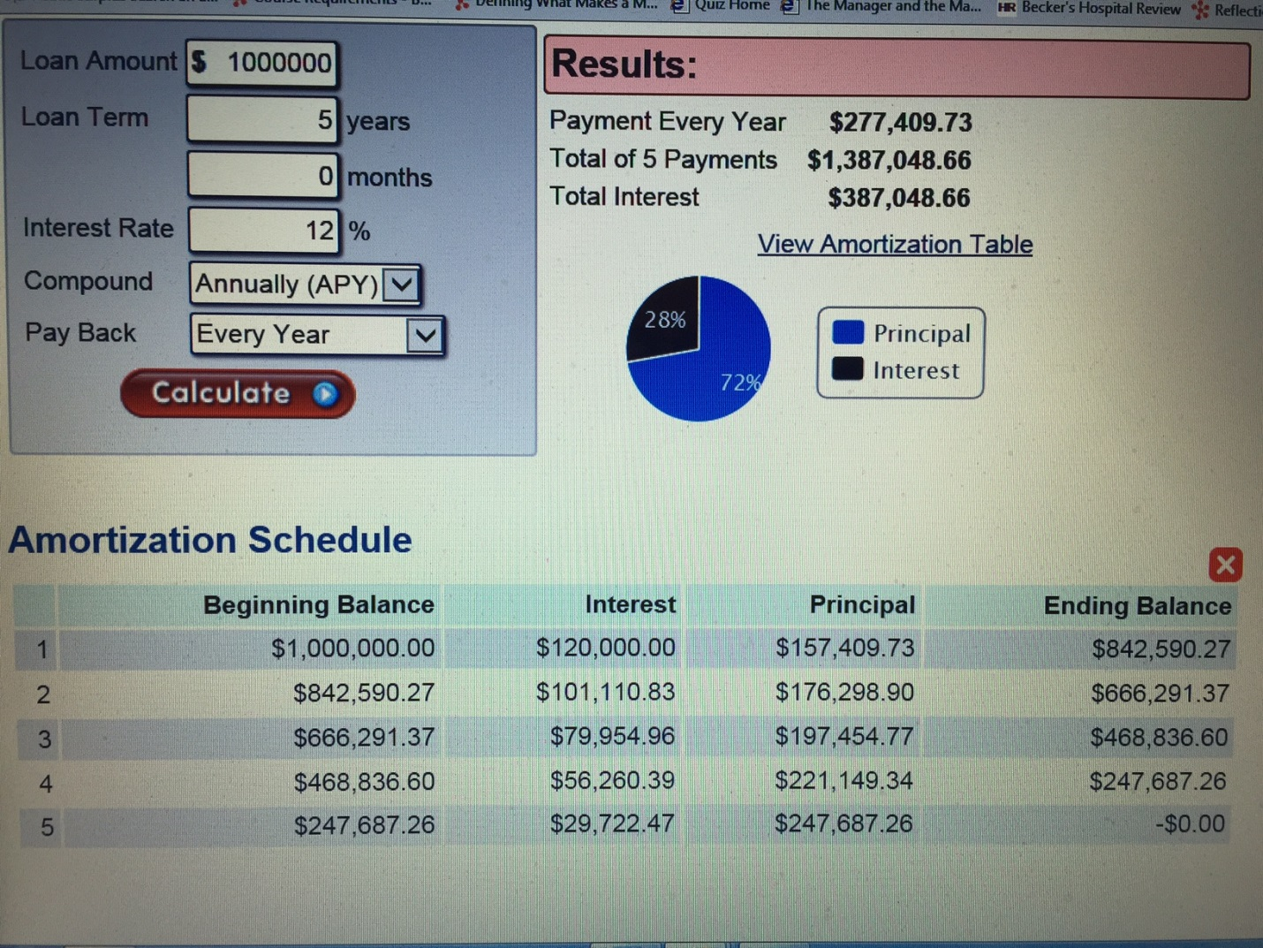

2.How do the interest payment, principal payment, and total payment change when the loan is amortized?
Changes that occur when the loan is fully amortized at the end of year five is there are no more interest payments, principal payments or payments at all the loan is fully paid back. Other changes that are clear is at the end of each of the five years the balance on the loan goes down years evenly in the amount of $277,409.73 each year once a payment is paid. In the first 2 years more money is paid in interest. After 2 to 3 years into the loan last couple years more money is paid to the principal of the loan. The loan balance goes down slightly faster each and every year until the end of year five for the loan is paid off and the loan is fully amortized

Part 2: Investments
1.Suppose the board were going to invest in an ordinary annuity requiring a payment of $10,000 over the next five years with an interest rate of 5%. What is the future value of this ordinary annuity investment? 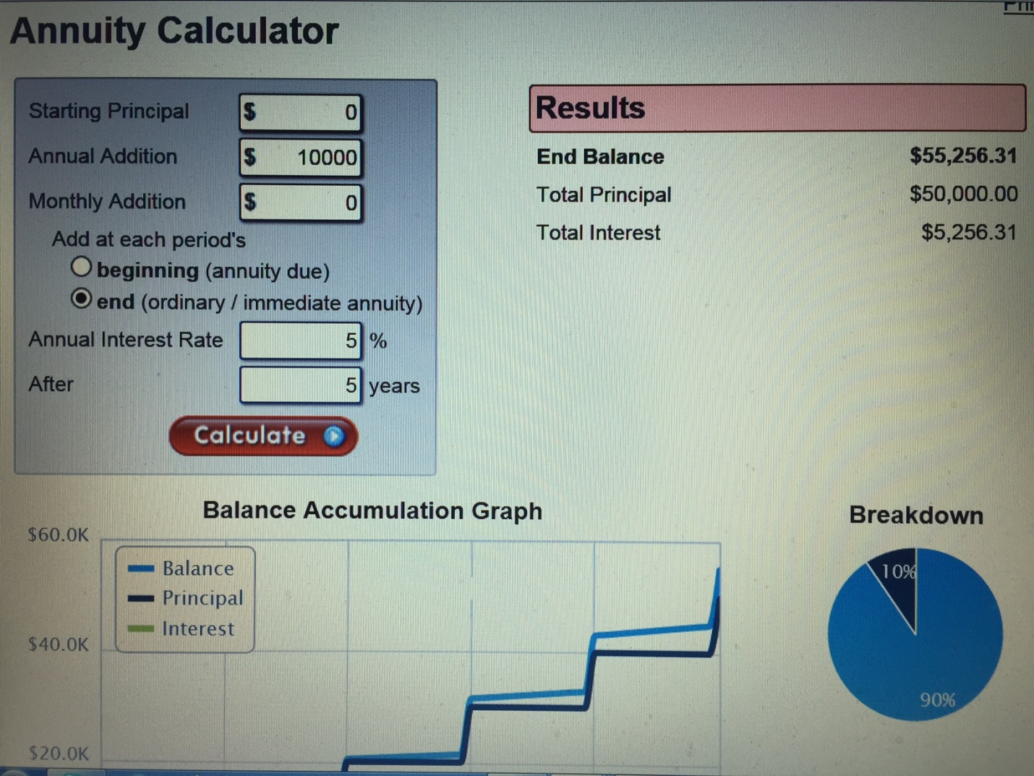
$10,000 paid in annually for 5 years at 5% interest. The future value of this Annuity is $ $55,256.31.
2.The board is considering other options for investing as well. For example, they want to double their investment of $70,000 over the next 12 years by using conventional securities with a projected return of 6%. Does the present value of the investment indicate that this is possible?
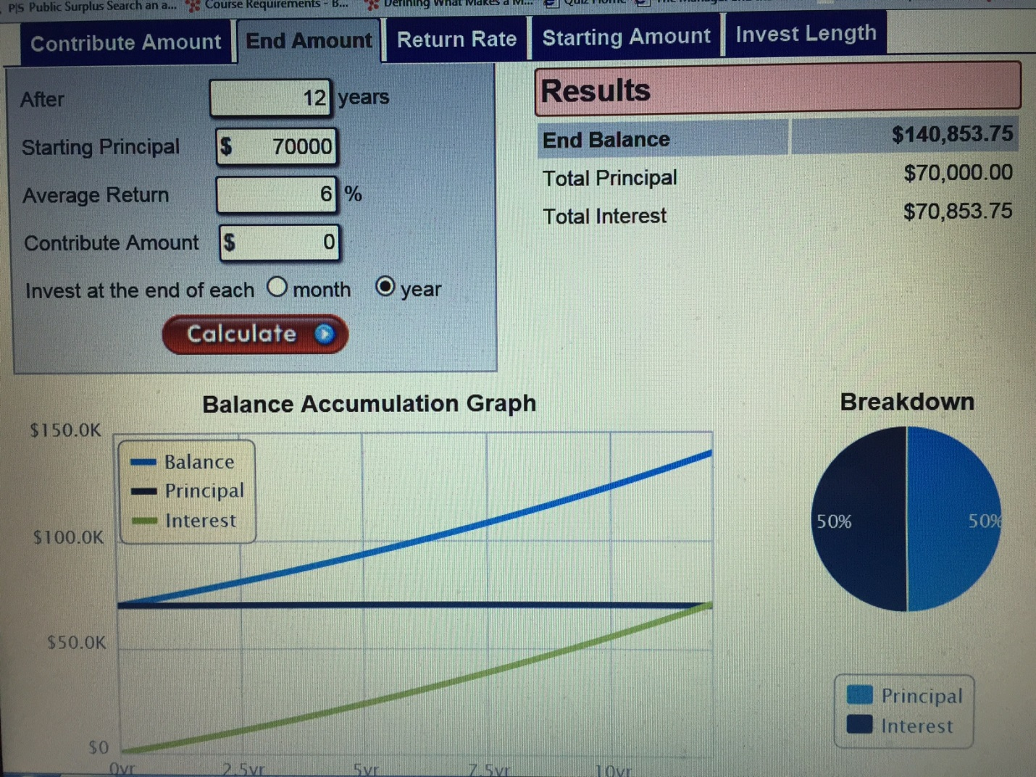
Based on initial investment of $70,000 utilizing conventional securities over 12 years at a projected return of 6% doubling their money to $140,000 is very possible. In fact calculations at 6% over 12 years come out to $140,853.75
3.What criteria should you examine in considering annuities? Include the common characteristics of variable annuity and equity-indexed annuity in your response.
When considering too buy an annuity there are several things that an individual should know. Many of annuities characteristics are similar but some are quite different and the buyer needs to be aware. First in annuity is a contract between an individual, and an insurance company. An annuity is in a method of converting saved income or wealth into a stream of income paid out over many years. An individual who has invested over time gives money to an insurance company for the insurance company to pay the investor benefit payments over a period of time starting right away or in the future. This is put into a contract. The two most common types annuities are an immediate life annuity and a deferred annuity. With the immediate life annuity the money is given to an insurance company then a contract is drawn out with the insurance company agreeing to immediately start paying the annuitant a set amount of money over the life of the annuity set in years. Annuities are often designed to give income through the end of one’s life.
With a deferred annuity often set amount money is given to an insurance company. Then over a period of time the individual continues to build up the annuity until the individual decides to retire or annuitize. Then once the annuitant decides to annuitize payments are paid out by the insurance company to the annuitant over a course of as many years as agreed upon in the annuity contract. It’s important to understand what fees are involved with purchasing. and maintaining an annuity. Some annuities have very large upfront costs to initially purchase. An average administrative fee is generally 0.10% to 0.25%. Often with large annuities over million dollars administrative fees are waived. Not all annuities are the same, and cost the same to maintain. I different insurance companies charge varying amounts to purchase, and maintain their annuity products so buyers beware!
Most annuities are set up to provide income to an individual until the end of their life. A very important thing the induvial needs to know is to determine whether the insurance company will stay solvent and make good on their promise to pay out when the time comes. Insurance companies are rated different ratings based on financial strength and solvency. Rating companies like Fitch, Moody, AM Best, and Standard poor’s rate these insurance companies. A superior rating being A up to AAA rating for most of the companies doing the rating. AM Best ratings are a little differently. A superior rating is A+ and A+ + for them. The solvency and financial strength of the insurance company that is chosen to purchase and annuity from is extremely important.
The type of annuity chosen is also very important. Annuities can be for an individual or two persons or even for a whole group. An annuity can be for a group of people like a group of employees for example. The different types of annuities to choose from generally are fixed, variable, and equity indexed. A fixed rate annuity is usually safe and fairly straight forward. This type annuity generally pays a guaranteed fixed amount of interest set by an insurance company. Variable interest annuity is generally attached to a financial vehicle or prime interest rate generally paying a guaranteed minimum amount of interest that varies depending upon the financial vehicle it’s attached too. An equity-indexed annuity is a fixed type of annuity that earns interest or provides benefits based on an equity index like the stock market or the S&P 500. This type of annuity goes up and down daily depending upon the vehicle is attached to. Depending on which annuity is right for the consumer annuities convert wealth into an income stream over the course of many years once annuitized. Annuities are often a great financial vehicle for those save money and finally live on the money they saved throughout their retirement.

